User-guide

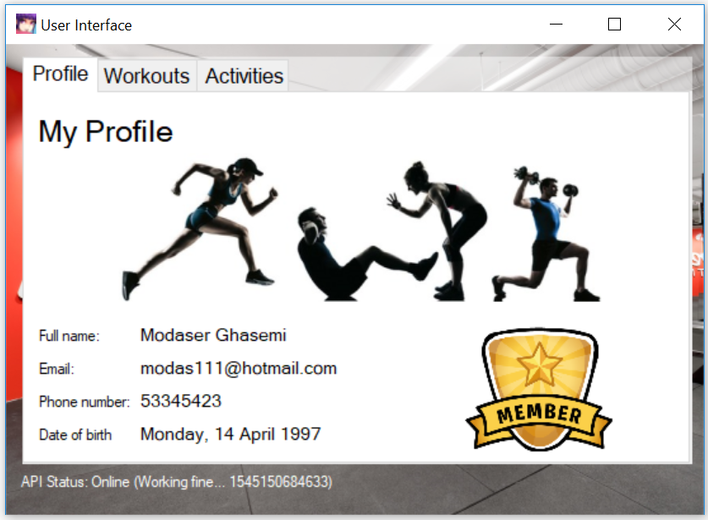

This is how the GUI will look like if you are a regular member.

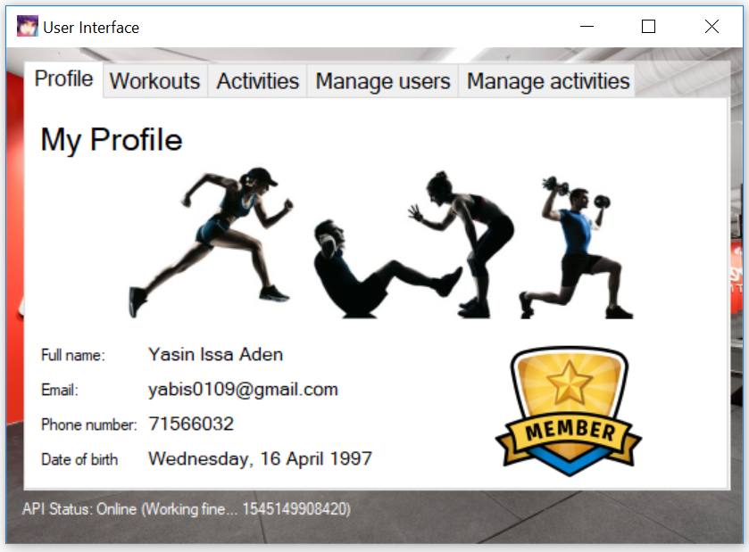

This is how the GUI will look like if you are an admin. As we can see there are 2 more tabs prior to a regular member.

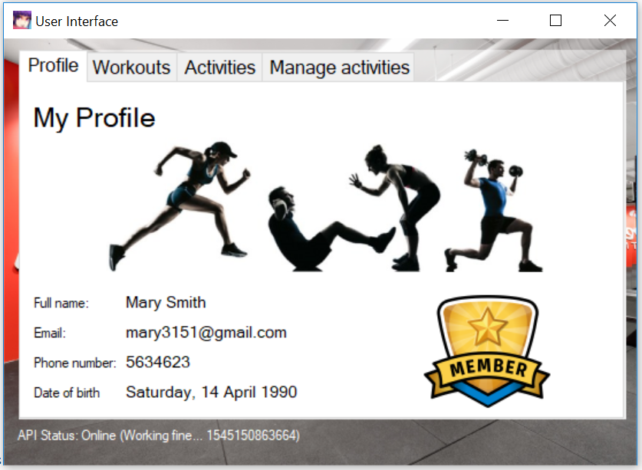

This is how the GUI will look like if you are an instructor. As we can see there is 1 more tab prior to a regular member.

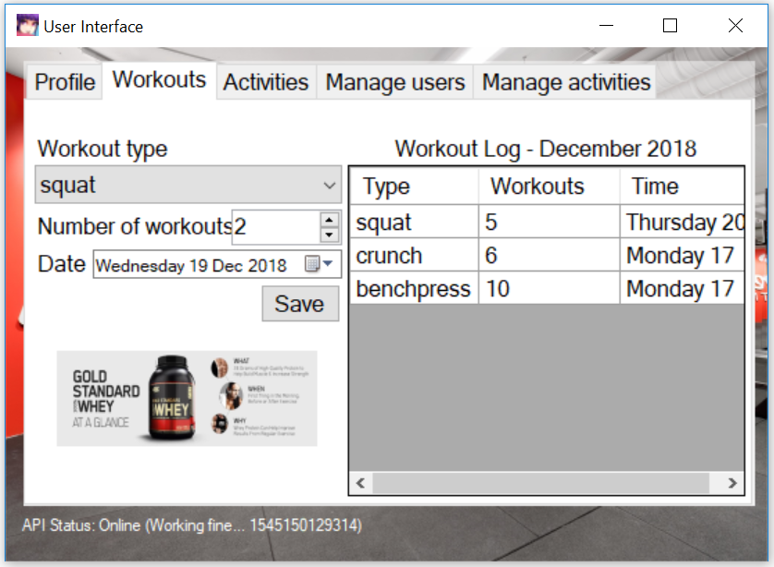

This is the workout tab. Here you can choose your workout-type and enter how many reps that has been done, then you set a date and saves it. It will then show it up on the workout log.

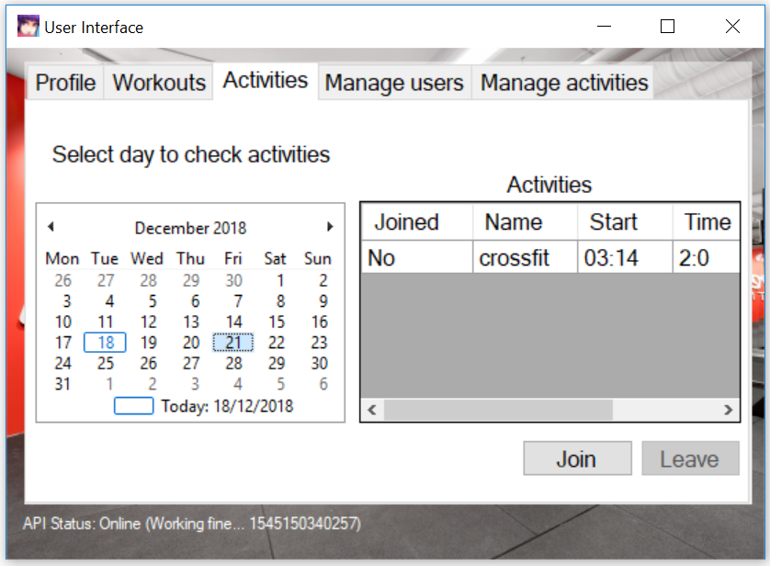

This is the activity tab. Here you can see the activities, you can also see whether or not you have joined the specific activity.

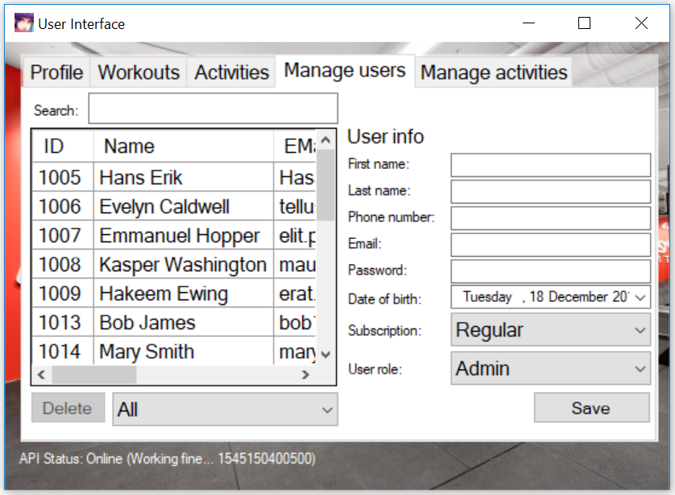

This is the manage user’s tab which is only visible to admins.

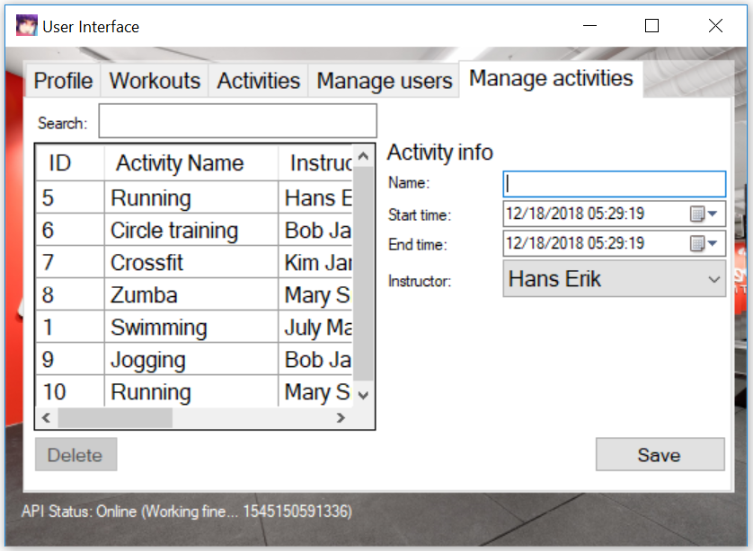

This is the manage activities tab, which is visible for both admin and instructor.